Experiment #5

Time Domain vs. Frequency Domain

EENG 275 - W01

Prepared for: M. Fakoor, Professor

New York Institute of Technology

Prepared by: V. Cavalcante, Student

Partnered with: Bibek Rout, Student

New York Institute of Technology

November 1st, 2019

**Experiment Objectives**

* Familiarize with the calculation for the Voltage Source and Voltage Capacitor of a RC Circuit
* Familiarize with the calculation for the Voltage Source and Voltage Inductor of a RL Circuit
* Understand time and frequency domains

**Equipment Used**

1- NYIT supplied Lab Kit

1- Function Generator

1- Oscilloscope

1- Digital Multi-meter (DMM)

1- DC Power Supply

1- 51 Ω Resistor

1- 220 Ω Resistor

1- 3 k Ω Resistor

1- 0.01 µF Capacitor

1- 10mH Inductor

**Results**

**Circuit 5.1 Measurements:**

Vs = 5.52V

Vc(t) = 10.8V

Vc Rise time = 62.40 microseconds

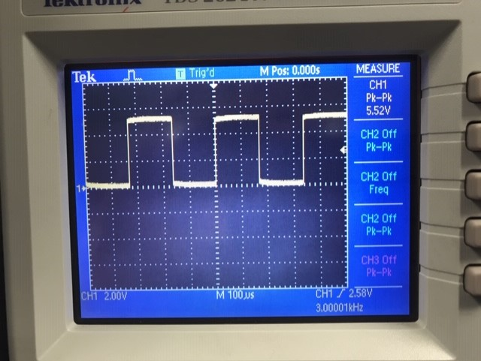 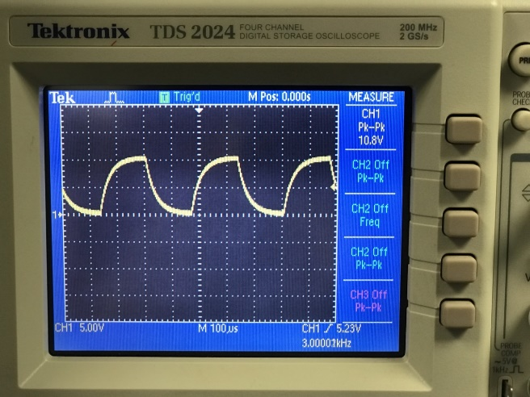

**Vs Circuit 1 Vc Circuit 1**

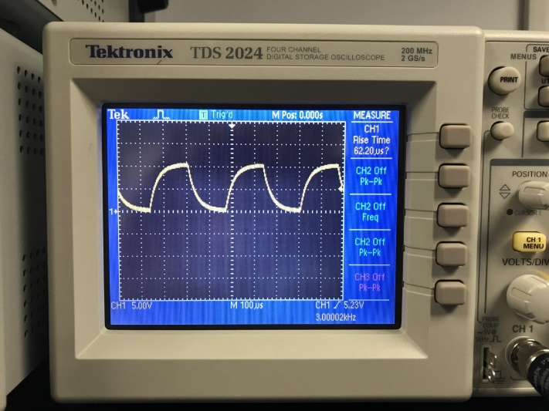

**Rising Time Circuit 1**

**Circuit 5.2 Measurements:**

Vs = 11.4V

Vc(t) = 18.6V

Vc Rise time = 125 nanoseconds

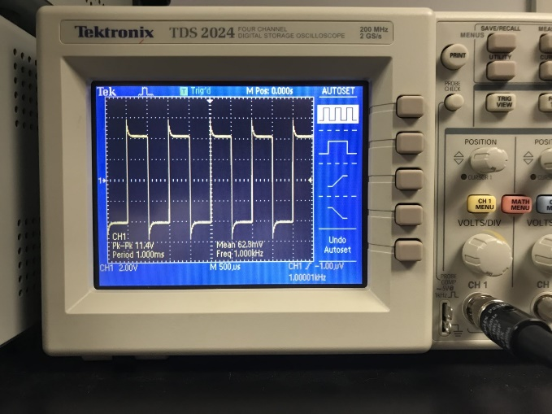 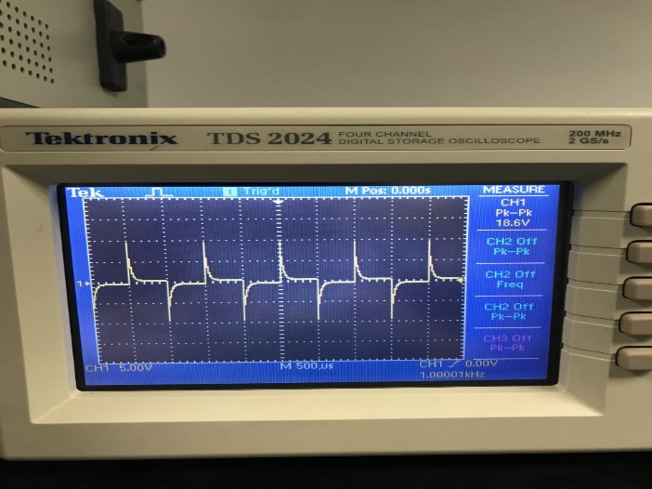

**Vs Circuit 2 Vl Circuit 2**

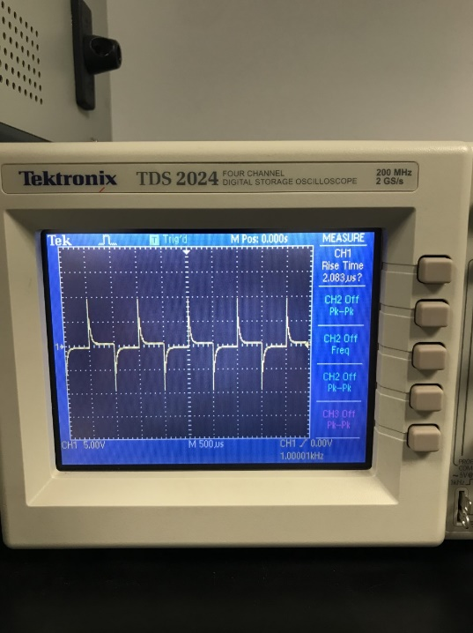

**Rising Time Circuit 2**

**Conclusion**

* With a large change in frequency the total voltage change gradually decreases
* To calculate for the rising time, it is necessary to measure with the bound between 10% – 90% of the rising function.
* Through the Measure button on the oscilloscope we were able to measure the necessary peak to peak voltages and the rising time for both the voltage of the capacitor and the voltage of the inductor.